## User Interface Design

### Guest Interface Design

#### Register

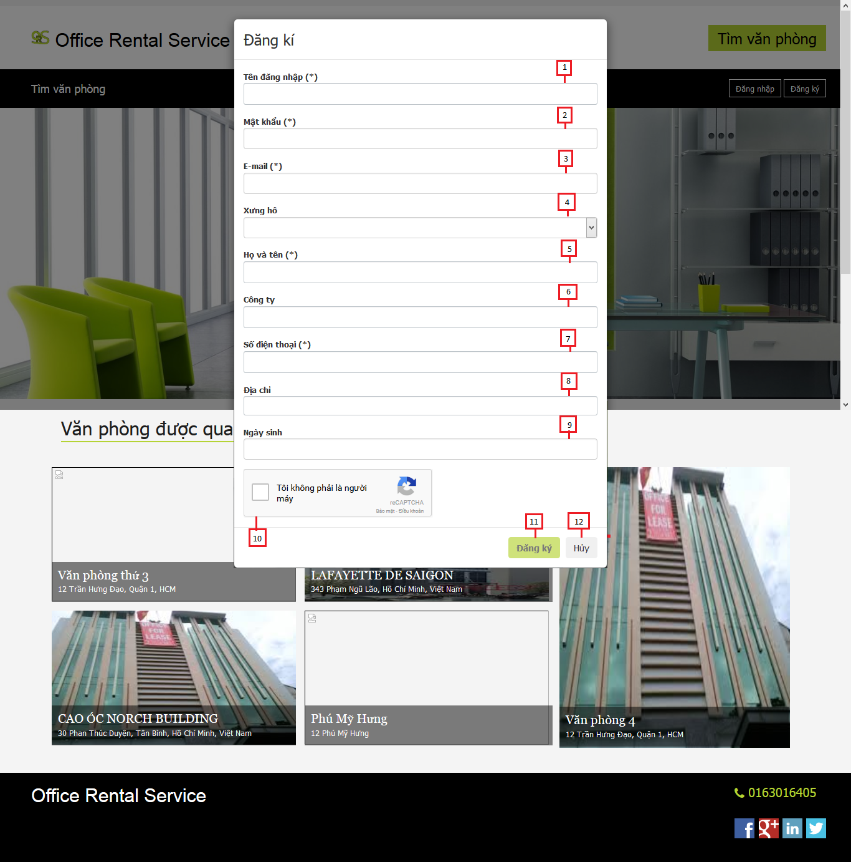

Figure 1: Register

**Fields**

|  |  |  |  |  |  |  |  |
| --- | --- | --- | --- | --- | --- | --- | --- |
| **No** | **Field Name** | **Description** | **Read only** | **Mandatory** | **Control Type** | **Data Type** | **Length** |
| 1 | Username | Fill username | No | Yes | Textbox | String | [3-50] |
| 2 | Password | Fill password | No | Yes | Password | String | [8-20] |
| 3 | Email | Fill user email | No | Yes | Textbox | String | 30 |
| 4 | Title | Fill user title | No | Yes | Drop-down list | String | N/A |
| 5 | Full name | Fill user full name | No | Yes | Textbox | String | [6-50] |
| 6 | Company | Fill user company | No | Yes | Textbox | String | 50 |
| 7 | Phone | Fill user phone | No | Yes | Textbox | String | [10-11] |
| 8 | Address | Fill user address | No | Yes | Textbox | String | 100 |
| 9 | Birthday | Fill user birthday | No | Yes | Date time picker | Date | N/A |

**Buttons/Hyperlinks**

|  |  |  |  |  |
| --- | --- | --- | --- | --- |
| **No** | **Function** | **Description** | **Validation** | **Outcome** |
| 10 | Captcha | Avoid spam | Yes | Can click register button |
| 11 | Register | Register new account | Yes | Close pop-up and show message |
| 12 | Cancel | Cancel register new account | N/A | Close pop-up |

### Customer Interface Design

#### Extend contract

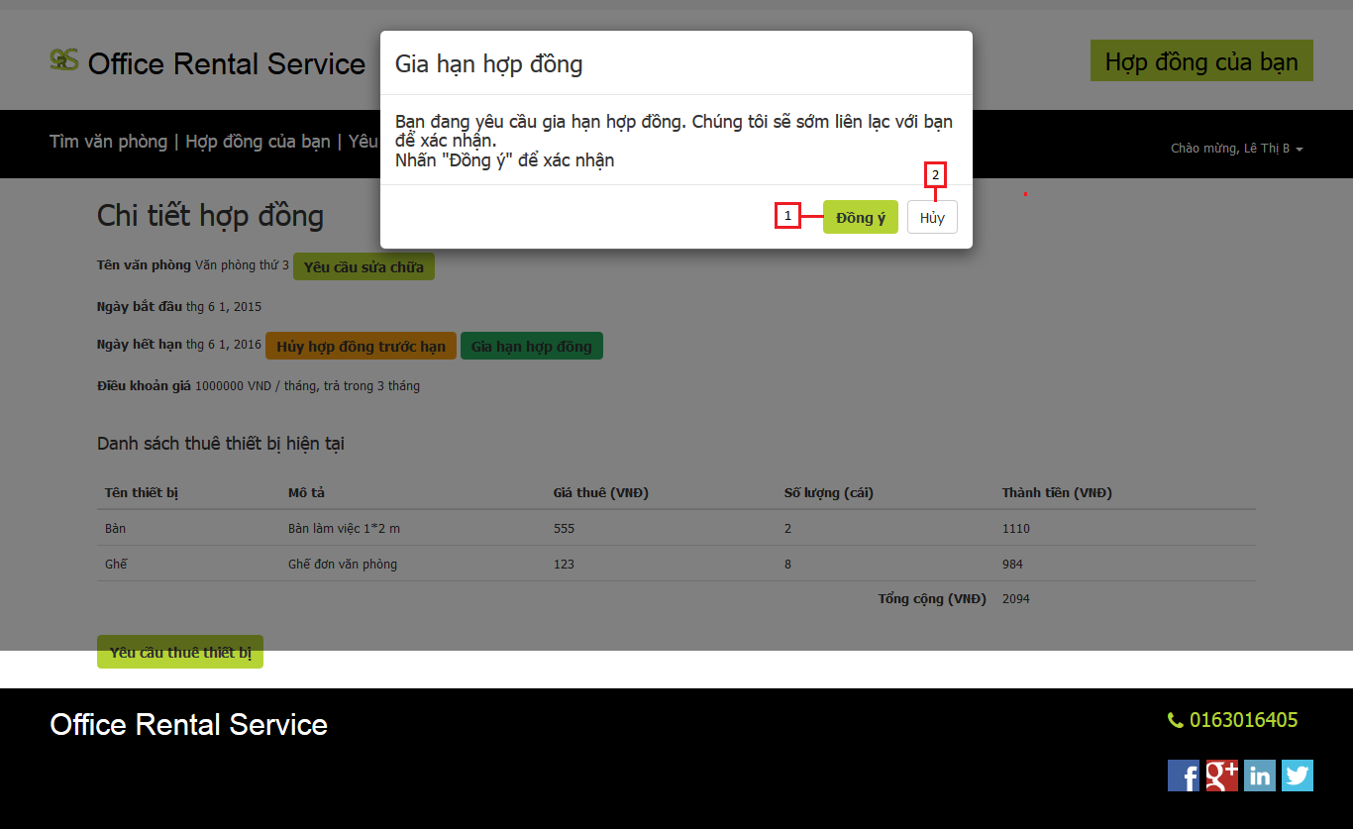

Figure 2: Extend Contract

**Buttons/Hyperlinks**

|  |  |  |  |  |
| --- | --- | --- | --- | --- |
| **No** | **Function** | **Description** | **Validation** | **Outcome** |
| 1 | Extend contract | Send request extend contract | N/A | Close pop-up and show message |
| 2 | Cancel | Cancel request extend contract | N/A | Close pop-up |

#### Return contract

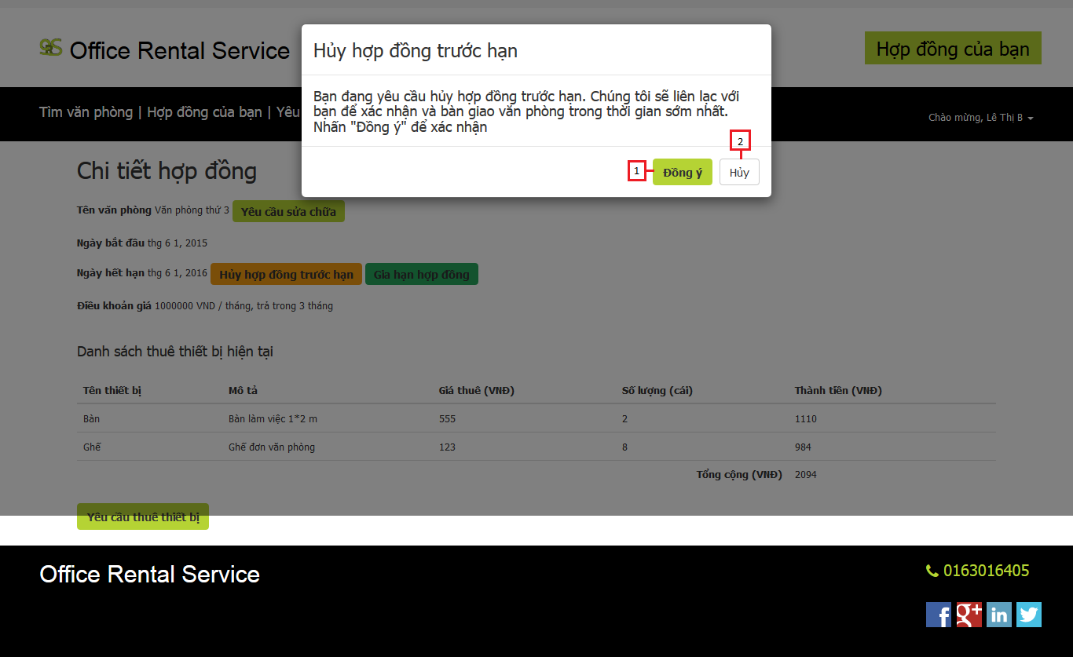

Figure 3: Return contract

**Buttons/Hyperlinks**

|  |  |  |  |  |
| --- | --- | --- | --- | --- |
| **No** | **Function** | **Description** | **Validation** | **Outcome** |
| 1 | Return contract | Send request return contract | N/A | Close pop-up and show message |
| 2 | Cancel | Cancel request return contract | N/A | Close pop-up |

#### Contract list

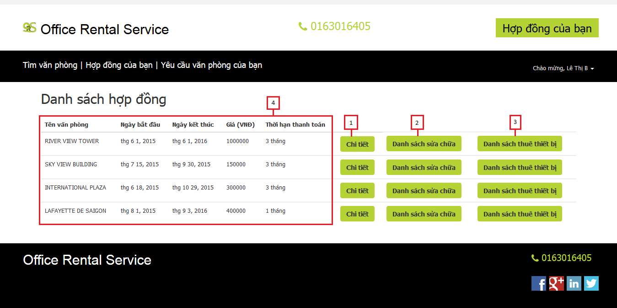

Figure 4: Contract list

**Fields**

|  |  |  |  |  |  |  |  |
| --- | --- | --- | --- | --- | --- | --- | --- |
| **No** | **Field Name** | **Description** | **Read only** | **Mandatory** | **Control Type** | **Data Type** | **Length** |
| 4 | List contract | List contract of customer. | Yes | Yes | Table | N/A | N/A |

**Buttons/Hyperlinks**

|  |  |  |  |  |
| --- | --- | --- | --- | --- |
| **No** | **Function** | **Description** | **Validation** | **Outcome** |
| 1 | Contract detail | View contract detail of customer. | N/A | Transfer to contract detail page |
| 2 | List request repair | View list request repair of customer. | N/A | Transfer to list request repair page |
| 3 | List request rental | View list request rental of customer. | N/A | Transfer to list request rental page |

**List contract include**

|  |  |  |  |  |  |
| --- | --- | --- | --- | --- | --- |
| **Field Name** | **Description** | **Read only** | **Control Type** | **Data Type** | **Length** |
| Office name | Name of current office. | Yes | Label | String | N/A |
| Start date | The effect date of the contract | Yes | Label | Date | N/A |
| End date | The date that the contract expire | Yes | Label | Date | N/A |
| Price | The price that customer paid in one month | Yes | Label | Integer | N/A |
| Price term | The time that customer paid cyclically | Yes | Label | String | N/A |

#### Contract detail

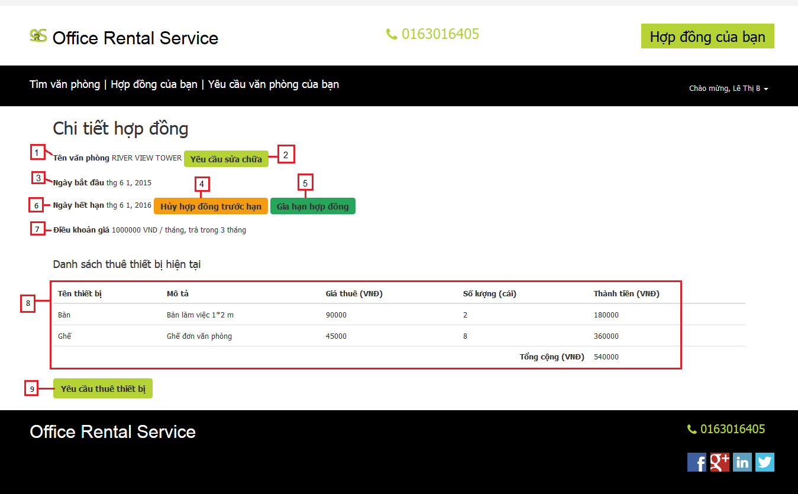

Figure 5: Contract detail

**Fields**

|  |  |  |  |  |  |  |  |
| --- | --- | --- | --- | --- | --- | --- | --- |
| **No** | **Field Name** | **Description** | **Read only** | **Mandatory** | **Control Type** | **Data Type** | **Length** |
| 1 | Office name | Name of current office. | Yes | Yes | Label | String | N/A |
| 3 | Start date | The effect date of the contract | Yes | Yes | Label | Date | N/A |
| 6 | End date | The date that the contract expire | Yes | Yes | Label | Date | N/A |
| 7 | Price | The price that customer paid in one month | Yes | Yes | Label | Integer | N/A |
| 8 | List rental item | List rental item that customer are hiring | Yes | Yes | Table | N/A | N/A |

**Buttons/Hyperlinks**

|  |  |  |  |  |
| --- | --- | --- | --- | --- |
| **No** | **Function** | **Description** | **Validation** | **Outcome** |
| 2 | Request repair | Click to send request repair | N/A | Transfer to request repair page |
| 4 | Request return contract | Click to send request return contract | Yes | Show pop-up request return contract |
| 5 | Request extend contract | Click to send request extend contract | Yes | Show pop-up request extend contract |
| 9 | Request rental | Click to send request rental item | N/A | Transfer to request rental item page |

**List rental item include**

|  |  |  |  |  |  |
| --- | --- | --- | --- | --- | --- |
| **Field Name** | **Description** | **Read only** | **Control Type** | **Data Type** | **Length** |
| Rental item name | The name of the rental item | Yes | Textview | String | N/A |
| Description | Describe request repair of customer | Yes | Textview | String | N/A |
| Unit price | Rent cost of one item | Yes | Textview | Integer | N/A |
| Quantity | The number of item is hiring | Yes | Textview | Integer | N/A |
| Item price | The price of all hired item | Yes | Textview | Integer | N/A |
| Total price | The sum of item price | Yes | Textview | Integer | N/A |

#### List request repair history

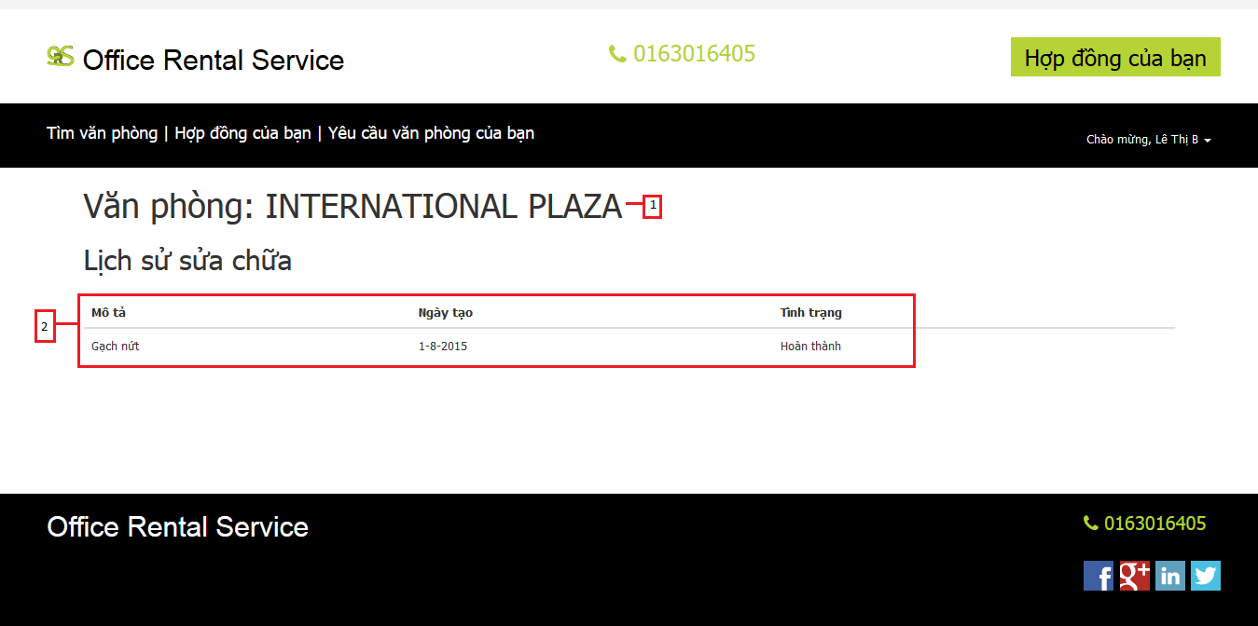

Figure 6: List request repair history

**Fields**

|  |  |  |  |  |  |  |  |
| --- | --- | --- | --- | --- | --- | --- | --- |
| **No** | **Field Name** | **Description** | **Read only** | **Mandatory** | **Control Type** | **Data Type** | **Length** |
| 1 | Office name | Name of the office | Yes | Yes | Label | String | N/A |
| 2 | List repair history detail | List all request repair that had completed or cancel. | Yes | Yes | Table | N/A | N/A |

**List repair history detail include**

|  |  |  |  |  |  |
| --- | --- | --- | --- | --- | --- |
| **Field Name** | **Description** | **Read only** | **Control Type** | **Data Type** | **Length** |
| Description | Describe request repair of customer | Yes | Textview | String | N/A |
| Create time | The time that customer create request | Yes | Textview | Date | N/A |
| Status | The status of request repair | Yes | Textview | String | N/A |

#### List request repair

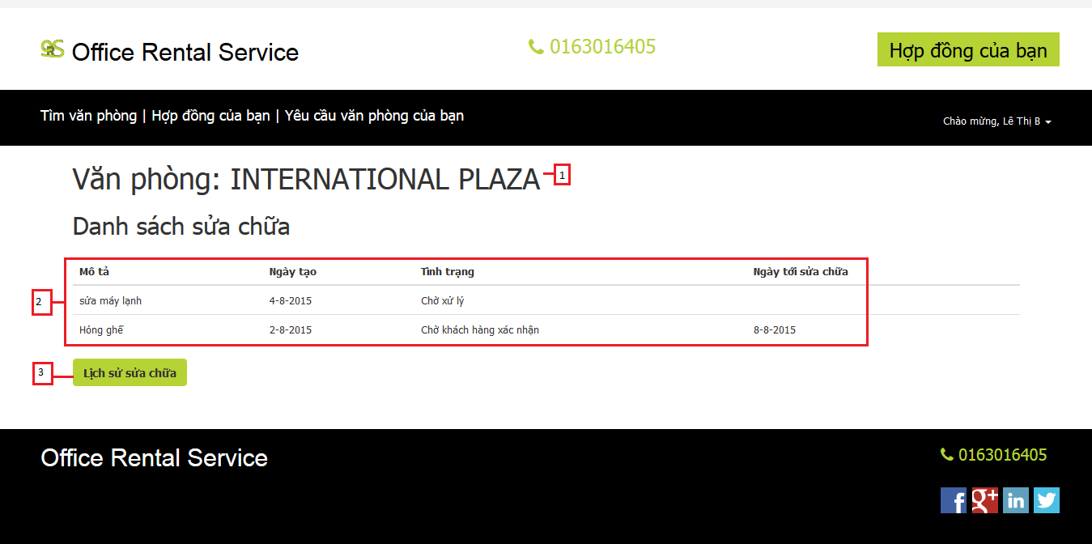

Figure 7: List request repair

**Fields**

|  |  |  |  |  |  |  |  |
| --- | --- | --- | --- | --- | --- | --- | --- |
| **No** | **Field Name** | **Description** | **Read only** | **Mandatory** | **Control Type** | **Data Type** | **Length** |
| 1 | Office name | The name of the office | Yes | Yes | Label | String | N/A |
| 2 | List repair detail | List request repair that wasn’t fixed. | Yes | Yes | Table | N/A | N/A |

**Buttons/Hyperlinks**

|  |  |  |  |  |
| --- | --- | --- | --- | --- |
| **No** | **Function** | **Description** | **Validation** | **Outcome** |
| 3 | Repair history | View list request repair that had completed or cancel. | N/A | Transfer to repair history page |

**List repair detail include**

|  |  |  |  |  |  |
| --- | --- | --- | --- | --- | --- |
| **Field Name** | **Description** | **Read only** | **Control Type** | **Data Type** | **Length** |
| Description | Describe request repair of customer | Yes | Textview | String | N/A |
| Create time | The time that customer create request | Yes | Textview | Date | N/A |
| Status | The status of request repair | Yes | Textview | String | N/A |
| Assigned time | The time that staff will come to fix | Yes | Textview | Date | N/A |

#### Profile

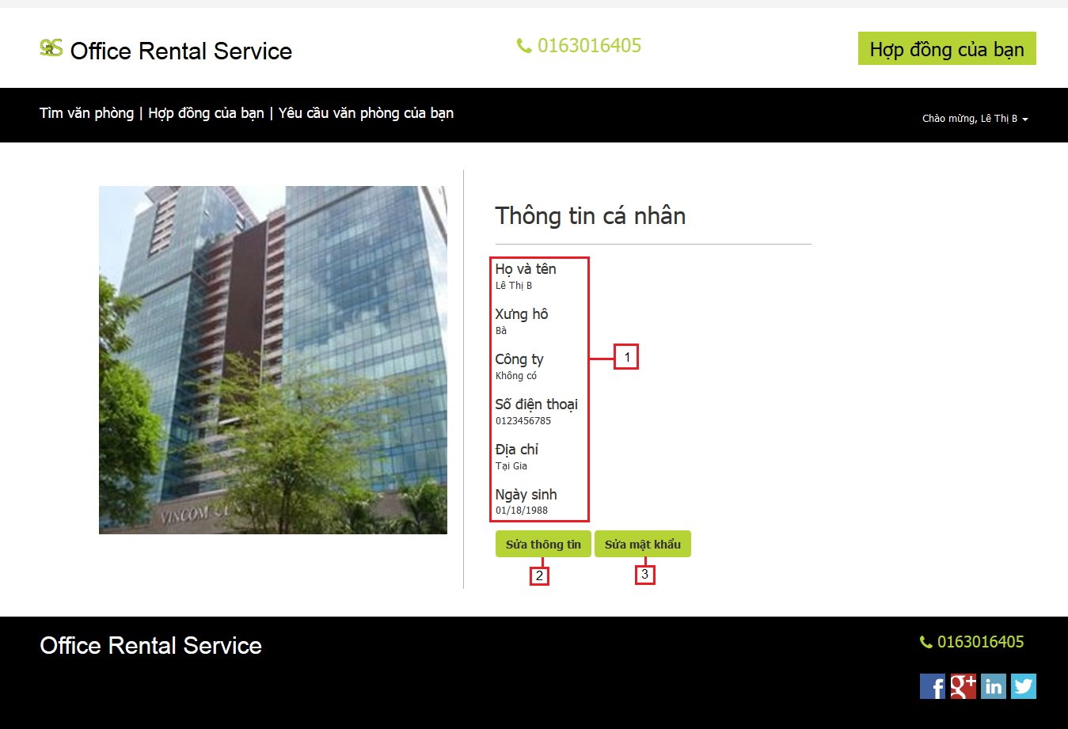

Figure 8: Profile

**Fields**

|  |  |  |  |  |  |  |  |
| --- | --- | --- | --- | --- | --- | --- | --- |
| **No** | **Field Name** | **Description** | **Read only** | **Mandatory** | **Control Type** | **Data Type** | **Length** |
| 1 | Information profile | Description information about customer | Yes | Yes | Label | String | N/A |

**Buttons/Hyperlinks**

|  |  |  |  |  |
| --- | --- | --- | --- | --- |
| **No** | **Function** | **Description** | **Validation** | **Outcome** |
| 2 | Edit information | Update profile of customer | N/A | Transfer to edit information page |
| 3 | Change password | Update password of customer | N/A | Transfer to change password page |

#### Profile detail

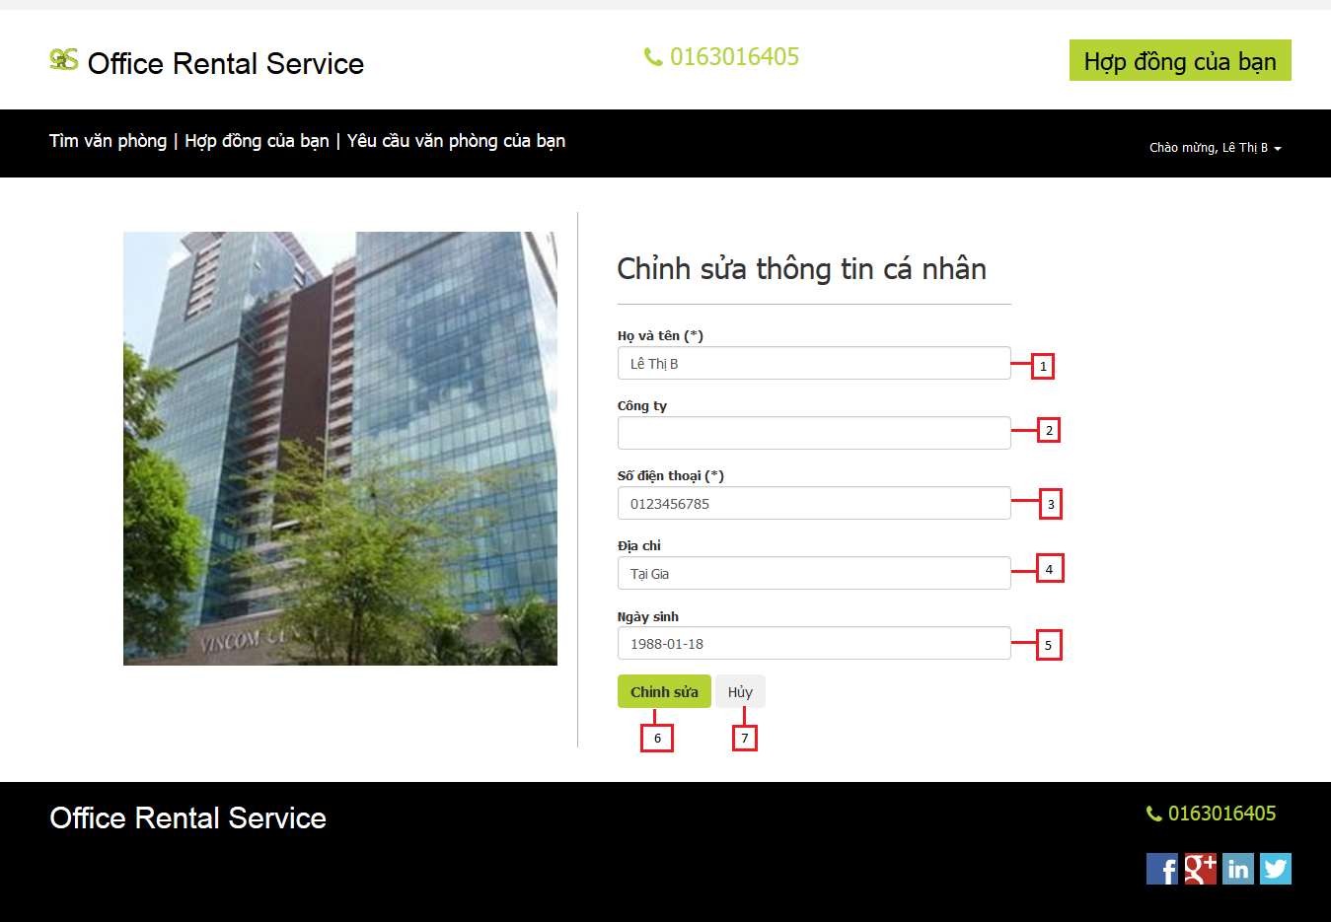

Figure 9: Profile detail

**Fields**

|  |  |  |  |  |  |  |  |
| --- | --- | --- | --- | --- | --- | --- | --- |
| **No** | **Field Name** | **Description** | **Read only** | **Mandatory** | **Control Type** | **Data Type** | **Length** |
| 1 | Full name | Fill user full name | No | Yes | Textbox | String | [6-50] |
| 2 | Company | Fill user company | No | Yes | Textbox | String | 50 |
| 3 | Phone | Fill user phone | No | Yes | Textbox | String | [10-11] |
| 4 | Address | Fill user address | No | Yes | Textbox | String | 100 |
| 5 | Birthday | Fill user birthday | No | Yes | Date time picker | Date | N/A |

**Buttons/Hyperlinks**

|  |  |  |  |  |
| --- | --- | --- | --- | --- |
| **No** | **Function** | **Description** | **Validation** | **Outcome** |
| 6 | Edit profile | Update profile of customer | Yes | Return profile page and show message |
| 7 | Cancel | Cancel edit profile | N/A | Return profile page |

#### Change password

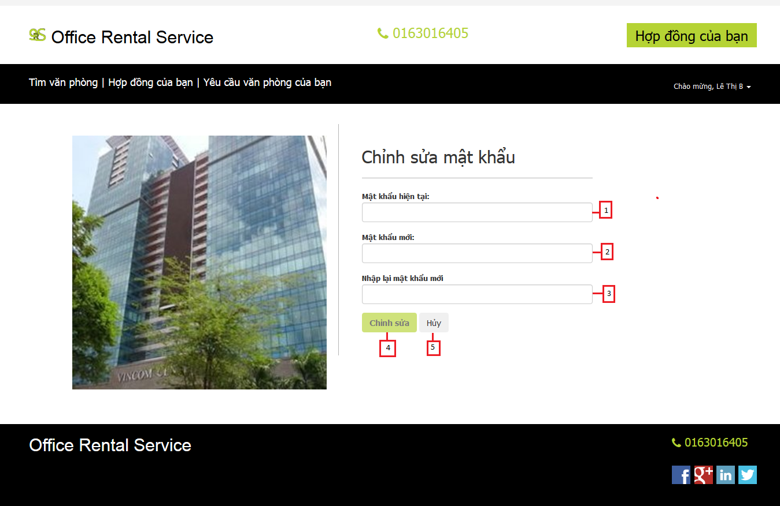

Figure 10: Change password

**Fields**

|  |  |  |  |  |  |  |  |
| --- | --- | --- | --- | --- | --- | --- | --- |
| **No** | **Field Name** | **Description** | **Read only** | **Mandatory** | **Control Type** | **Data Type** | **Length** |
| 1 | Password | Fill user password | No | Yes | Textbox | String | [8-20] |
| 2 | New password | Input new password | No | Yes | Textbox | String | [8-20] |
| 3 | Re-password | Retype new password | No | Yes | Textbox | String | [8-20] |

**Buttons/Hyperlinks**

|  |  |  |  |  |
| --- | --- | --- | --- | --- |
| **No** | **Function** | **Description** | **Validation** | **Outcome** |
| 6 | Edit password | Update new password of customer | Yes | Return profile page and show message |
| 7 | Cancel | Cancel edit password | N/A | Return profile page |

#### Office detail

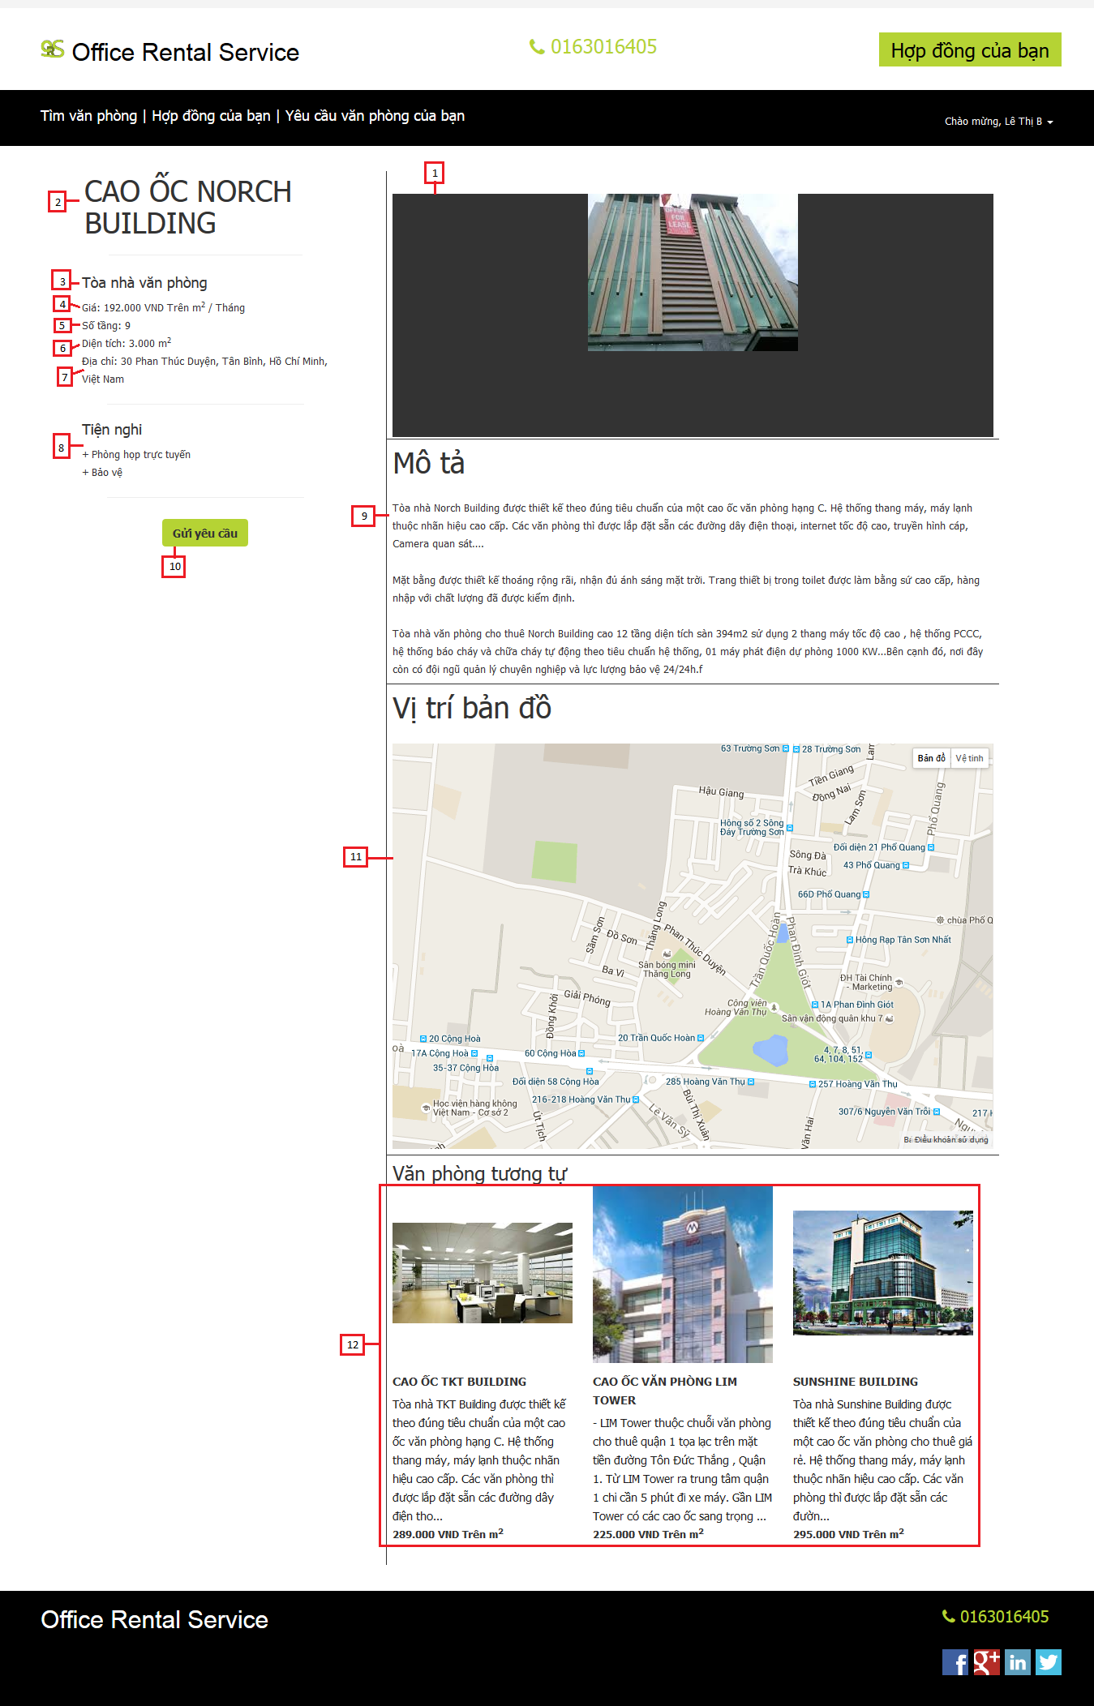

Figure 11: Office detail

**Fields**

|  |  |  |  |  |  |  |  |
| --- | --- | --- | --- | --- | --- | --- | --- |
| **No** | **Field Name** | **Description** | **Read only** | **Mandatory** | **Control Type** | **Data Type** | **Length** |
| 1 | Office image | The image of the office | Yes | Yes | Image | N/A | N/A |
| 2 | Office name | The name of the office | Yes | Yes | Label | String | N/A |
| 3 | Category | The category of the office | Yes | Yes | Label | String | N/A |
| 4 | Price | The rent cost of the office in a month | Yes | Yes | Label | Integer | N/A |
| 5 | Floor | Number of floor in the office | Yes | Yes | Label | Integer | N/A |
| 6 | Area | Total area of the office | Yes | Yes | Label | Integer | N/A |
| 7 | Address | The address of the office | Yes | Yes | Label | String | N/A |
| 8 | Amenity | The amenity of the office | Yes | Yes | List | N/A | N/A |
| 9 | Description | The description of the office | Yes | Yes | Paragraph | String | N/A |
| 11 | Maps | Show office address on maps | Yes | Yes | Google map | N/A | N/A |
| 12 | Suggest office | List office that are the same this office | Yes | Yes | List | N/A | N/A |

**Buttons/Hyperlinks**

|  |  |  |  |  |
| --- | --- | --- | --- | --- |
| **No** | **Function** | **Description** | **Validation** | **Outcome** |
| 10 | Request appointment | Click to request appointment | N/A | Transfer to request appointment page |

**Suggest office include**

|  |  |  |  |  |  |
| --- | --- | --- | --- | --- | --- |
| **Field Name** | **Description** | **Read only** | **Control Type** | **Data Type** | **Length** |
| Office name | The name of the office | Yes | Textview | String | N/A |
| Description | The description of the office | Yes | Textview | String | N/A |
| Price | The rent cost of the office | Yes | Textview | Integer | N/A |

#### Request office

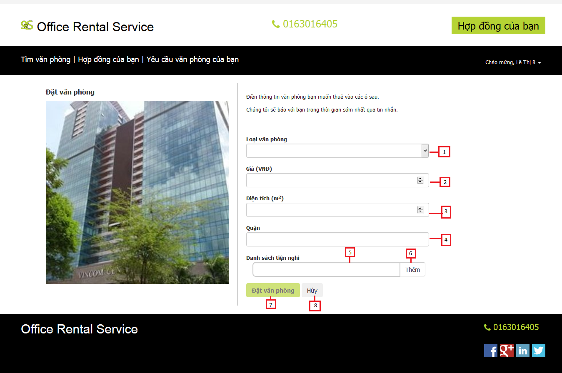

Figure 12: Request office

**Fields**

|  |  |  |  |  |  |  |  |
| --- | --- | --- | --- | --- | --- | --- | --- |
| **No** | **Field Name** | **Description** | **Read only** | **Mandatory** | **Control Type** | **Data Type** | **Length** |
| 1 | Category | The category of the office | No | Yes | Drop down list | String | N/A |
| 2 | Price | The price of the office | No | Yes | Textbox | Integer | N/A |
| 3 | Area | The area of the office | No | Yes | Textbox | Integer | N/A |
| 4 | District | The district that you want to find the office | No | Yes | Textbox | Integer | N/A |
| 5 | Amenity | The amenity of the office | No | Yes | Textbox | String | N/A |

**Buttons/Hyperlinks**

|  |  |  |  |  |
| --- | --- | --- | --- | --- |
| **No** | **Function** | **Description** | **Validation** | **Outcome** |
| 6 | Add amenity | Click to add amenity | N/A | Add amenity to the request |
| 7 | Request office | Click to send request office | Yes | Show message and transfer to home page |
| 8 | Cancel | Cancel request office | N/A | Transfer to home page |

#### Request repair

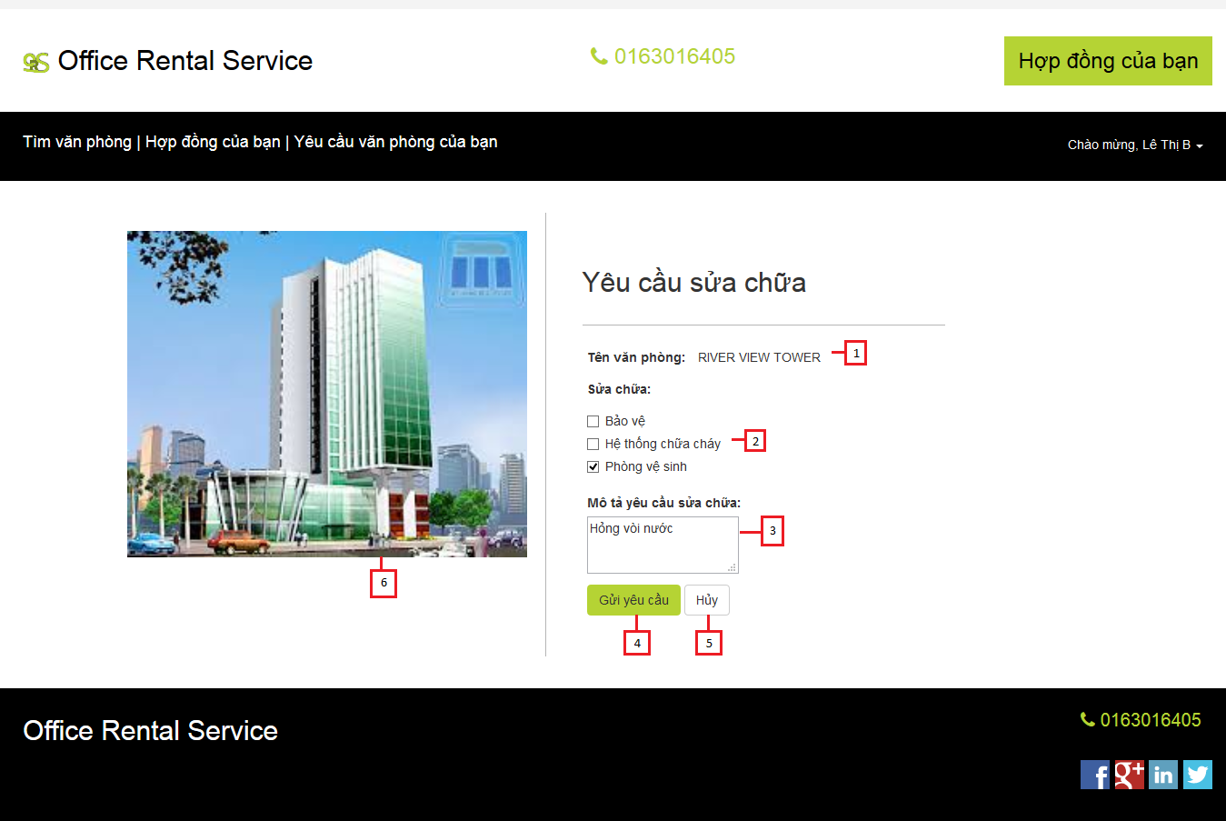

Figure 13: Request repair

**Fields**

|  |  |  |  |  |  |  |  |
| --- | --- | --- | --- | --- | --- | --- | --- |
| **No** | **Field Name** | **Description** | **Read only** | **Mandatory** | **Control Type** | **Data Type** | **Length** |
| 1 | Office name | The name of the office | Yes | Yes | Label | String | N/A |
| 2 | Amenity | The amenity of the office | No | Yes | Checkbox | N/A | N/A |
| 3 | Description | The description of the request repair | No | Yes | Textarea | String | N/A |
| 6 | Office image | The image of the office | Yes | Yes | Image | N/A | N/A |

**Buttons/Hyperlinks**

|  |  |  |  |  |
| --- | --- | --- | --- | --- |
| **No** | **Function** | **Description** | **Validation** | **Outcome** |
| 4 | Request repair | Click to send request repair | Yes | Show message and transfer to contract list page |
| 5 | Cancel | Cancel request office | N/A | Transfer to contract detail |

### Manager Interface Design

#### Repair

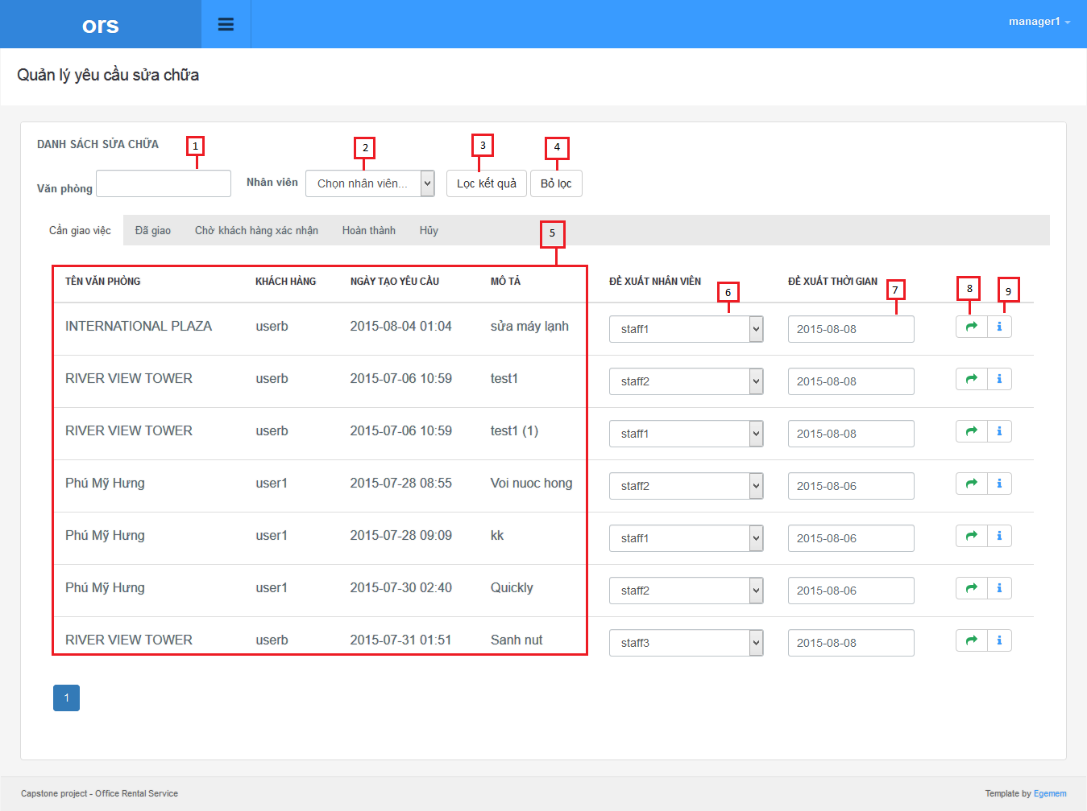

Figure 14: Repair

**Fields**

|  |  |  |  |  |  |  |  |
| --- | --- | --- | --- | --- | --- | --- | --- |
| **No** | **Field Name** | **Description** | **Read only** | **Mandatory** | **Control Type** | **Data Type** | **Length** |
| 1 | Office name | The name of the office | No | Yes | Textbox | String | N/A |
| 2 | Staff name | List staff name | No | Yes | Drop down list | String | N/A |
| 5 | List repair | List request repair of customer | Yes | Yes | Table | N/A | N/A |
| 6 | Assign staff | The staff that system suggest to manager | No | Yes | Drop down list | String | N/A |
| 7 | Assign time | The date that system suggest to manager | No | Yes | Date time picker | Date | N/A |

**Buttons/Hyperlinks**

|  |  |  |  |  |
| --- | --- | --- | --- | --- |
| **No** | **Function** | **Description** | **Validation** | **Outcome** |
| 3 | Filter | Filter list repair by office name or staff name | N/A | Show list repair after filter |
| 4 | Cancel filter | Click to cancel filter | N/A | Return list repair to entry |

**List repair include**

|  |  |  |  |  |  |
| --- | --- | --- | --- | --- | --- |
| **Field Name** | **Description** | **Read only** | **Control Type** | **Data Type** | **Length** |
| Office name | The name of the office | Yes | Textview | String | N/A |
| Username | Username of customer | Yes | Textview | String | N/A |
| Create time | The time that customer create request | Yes | Textview | Date | N/A |
| Description | Describe request repair of customer | Yes | Textview | String | N/A |

#### Repair detail

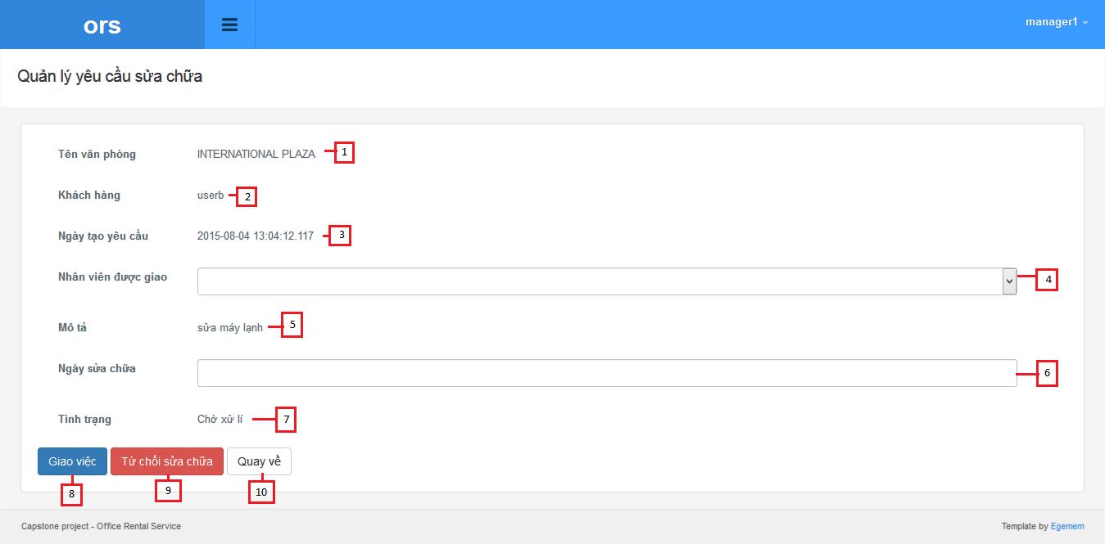

Figure 15: Repair detail

**Fields**

|  |  |  |  |  |  |  |  |
| --- | --- | --- | --- | --- | --- | --- | --- |
| **No** | **Field Name** | **Description** | **Read only** | **Mandatory** | **Control Type** | **Data Type** | **Length** |
| 1 | Office name | The name of the office | Yes | Yes | Label | String | N/A |
| 2 | Username | Username of customer | Yes | Yes | Label | String | N/A |
| 3 | Create time | The time that customer create request | Yes | Yes | Label | Date | N/A |
| 4 | Staff | List all of staff | No | Yes | Drop down list | String | N/A |
| 5 | Description | Describe request repair of customer | Yes | Yes | Label | String | N/A |
| 6 | Assign time | The date that staff come to repair | No | Yes | Drop down list | String | N/A |
| 7 | Status | The status of the request repair | Yes | Yes | Label | String | N/A |

**Buttons/Hyperlinks**

|  |  |  |  |  |
| --- | --- | --- | --- | --- |
| **No** | **Function** | **Description** | **Validation** | **Outcome** |
| 8 | Assign | Accept request and assign staff to repair | N/A | Return to repair page |
| 9 | Reject | Reject request | N/A | Return to repair page |
| 10 | Cancel | Click to cancel filter | N/A | Return to repair page |